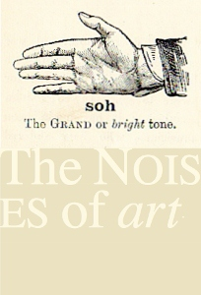 The Noises of art
Audiovisual Practice in History Theory and Culture

The School of art aberystwyth university
The Courtauld Institute of art, London & Aberystwyth arts Centre

4–6 September 2013, Aberystwyth Arts Centre

Booking Form (conference attenders):
Your Details
Name:
Email:

Accommodation:
Accommodation is available on campus for 3rd/4th & 5th of September at a cost of £30 per night
Arrival Date:
Departure Date:

Dietary requirements:
Tea/Coffee & Lunch are provided at the conference. If you have any dietary requirements please list these below: (I.e lactose/wheat/gluten intolerance, vegetarian, vegan or any food allergies)
Requirements:

Conference dinner:
We will be holding a conference dinner at Aberystwyth Arts Centre on the 5th of September. The cost is £15 per person.
Attending/Not attending:

Payment:
Conference Fee: £60 per person.
Payment for the conference, accommodation & conference dinner can be made by:
Cheque: payable to Aberystwyth University and post to: Sophie Bennett, The Noises of Art Conference, Aberystwyth Arts Centre, Aberystwyth University, Aberystwyth, Credigion SY23 3DE
By Bank Transfer:
Bank: Lloyds TSB Bank Plc
Branch: 1 Queen Street, Cardiff, CF10 2AF
Sort Code: 30-91-63
A/C No: 00307826
A/C Name: AU General a/c

Please email this form back to Sophie Bennett sob@aber.ac.uk or Gwen Morgan aafstaff@aber.ac.uk or post to the address above. We will confirm your place on the conference as soon as we receive this form, conference booking fee (£60 per person) and accommodation and conference dinner fee (if required).

